Lab 6

# Summary

This lab aims to teach us the concept of routing and updating static routing tables to route packages based on our needs.

Initially the above images is the architecture, but we need it so that each IP can be used to access another IP within this architecture. For this we update the routing table manually.

## Exercise 1

1. Route -n

1. eth1 and eth2 of node B and node C



Pinging eth1 of node B and eth2 of node C works, but eth2 of node B and eth1 of node C fail. This is because the current architecture is as shown below.

1. Traceroute 10.10.2.2 from node A

This happens because the routing table for node A does not know where to send the packets to for the IP 10.10.2.2.

Pinging from node A

## Exercise 2

Once we route node A to the other eths of node B and C, after pinging it, we see that the previously unreachable Ips are now reachable.

**Below are screenshots of the changed routing tables of node B and node C**

*Before we change the routing tables, we show inaccessible local IPs from B and C.*

***For B:***

***For C:***

***Updated routing table of B:***

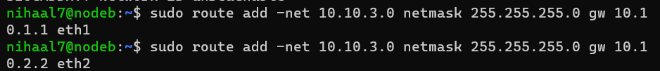

***Updated routing table of C:***

***Proof that node B is updated:***

***Proof that node C is updated:***

#### Traceroute on node B:

This confirms that our changes made on the routing table are correct and that all IPs are accessible within each other.

## Termination

